Practical 6

Section -G2903 name -priyanshu bansal

Registration no.- 11906705

***Aim :*** to design rectifier (half wave rectifier and full wave rectifier )and study effect of C-filter.

**Observation table and design** :

Half wave rectifier 🡺

Diagram :

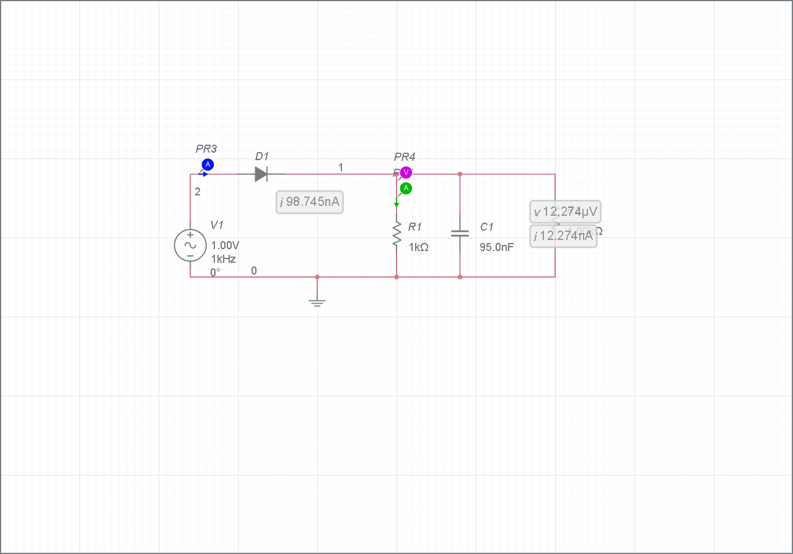

Observation table :

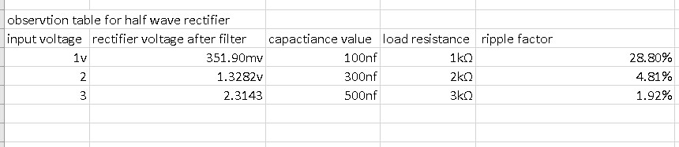

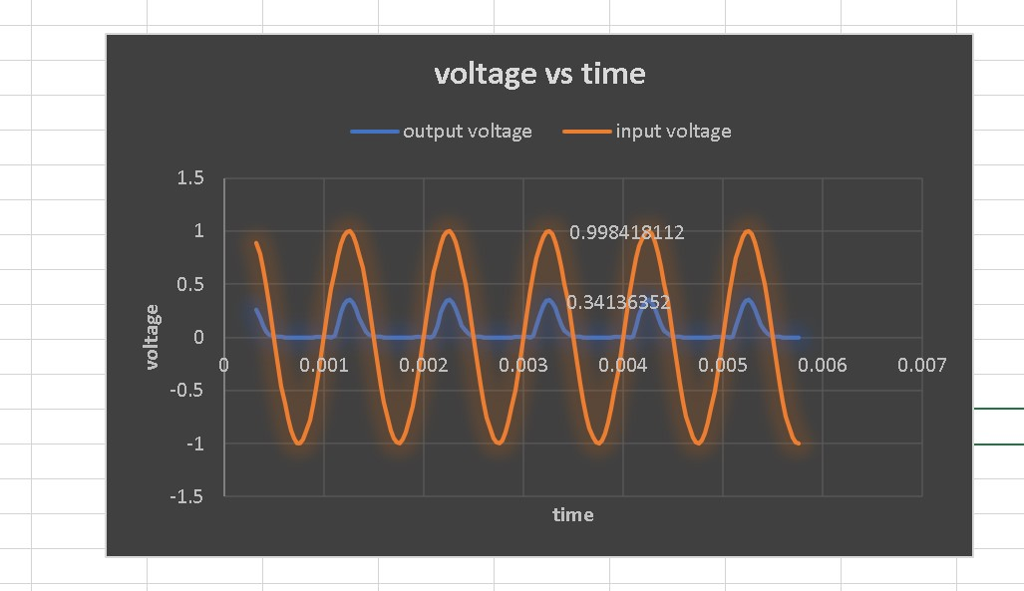

Calculation :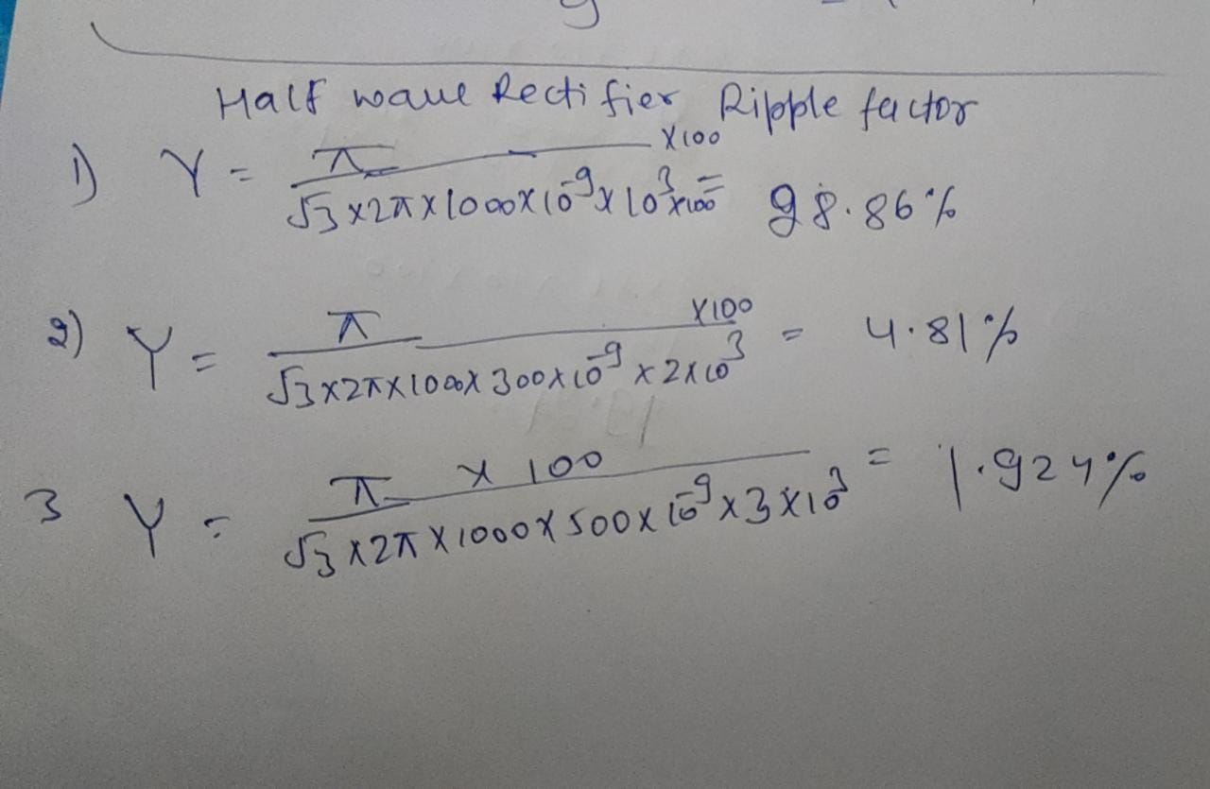

Full wave rectifier :

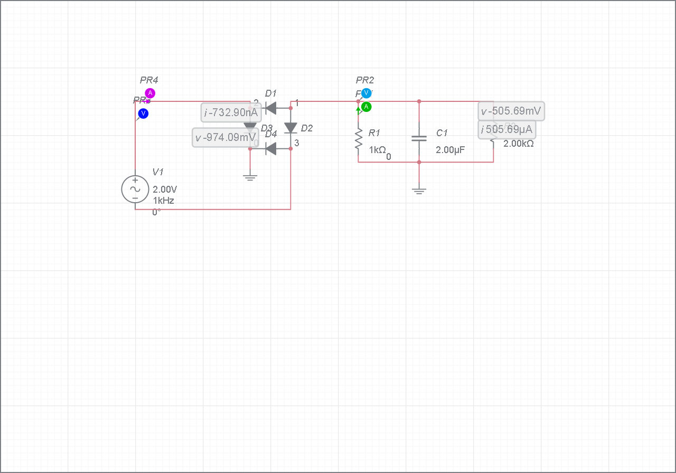Diagram:

Observation table :

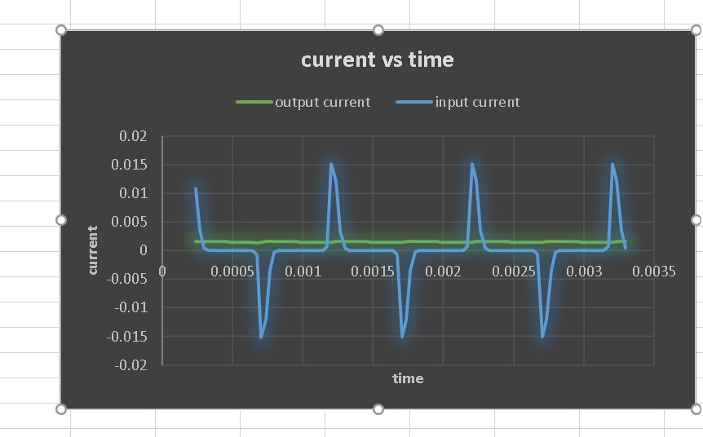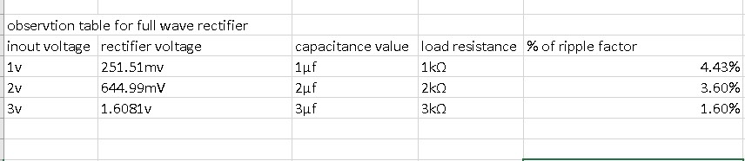

Calculation :

